**Optimising an evolutionary experiment to evolve nitrogen-fixing legume symbiosis in *Mesorhizobium australicum* BR1-1-5xICE*Ml*Sym**

Isaak Salami

**Abstract**

*Mesorhizobia* are soil bacteria able to establish a nitrogen-fixing symbiosis with legumes. During the symbiosis, they induce formation of root nodules within which they fix atmospheric nitrogen and convert it to ammonia. This nitrogenous compound is assimilated into the host legume where it promotes plant growth. In *Mesorhizobia*, the genes that encode for such symbiosis are harboured by mobile genetic elements called integrative and conjugative elements (ICESyms). Transfer of ICESyms into non-symbiotic *Mesorhizobia* can transform them into legume symbionts. However, the acquisition of the ICESyms does not always transform the recipient into symbiont able to fix nitrogen. This placement project aimed to optimise an evolutionary experiment that would attempt to evolve *M. australicum* BR1-1-5xICE*Ml*Sym into a successful nitrogen-fixing symbiont of various *Lotus* legumes. During this project, different species of *Lotus* were inoculated with *M. australicum* BR1-1-5xICE*Ml*Sym, and the quality of the symbiosis was assessed by both a nodulation assessment and weighing to assess plant growth. Nodules were then crushed into suspension to recover the symbionts for further rounds of evolution. *L. rectus* Tas2206 was most receptive to *M. australicum* BR1-1-5xICE*Ml*Sym symbiosis, whereas *L. australis* ID#3 and *L. uliginosus* GLOC005 displayed little-to-no success. Although *L. rectus* produced red nodules (usually indicative of nitrogen fixation) a One-Way ANOVA displayed that this was not correlated with a change in biomass. Of the three *Lotus* species assayed, *L. rectus* Tas2206 appears to be the most promising candidate with which to pursue the *M. australicum* BR1-1-5xICE*Ml*Sym evolutionary experiment. This study also aimed to confirm copper (Cu) resistance as a reliable identifier of an integrative and mobilizable element (IME) of interest present in two *Pseudomonas* isolates. However, the Cu minimum inhibitory concentration (MIC) assay displayed no increase in Cu MIC for the IME-carrying controls. As such, Cu resistance was found to be an unreliable indicator of the IME presence, and a different selection marker must be investigated.

**Introduction**

For my half-semester placement, I worked under the supervision of Dr Elena Colombi as part of her “*Functional integration of nitrogen-fixation in Australian indigenous rhizobia to improve soil fertility*” project. This project aims to identify the influence of a *Mesorhizobia’s* genetic background on their ability to ability to fix nitrogen during symbiosis with legumes. A symbiosis between a rhizobia and legumes is typically characterised by the formation of nodules on the legume’s roots1. These nodules, composed of differentiated plant cells, create a specialised environment to host the symbiotic rhizobia1. Inside the nodules, the bacteria and plant exchange nutrients with one another. A key function of the rhizobia in this relationship is the fixation of atmospheric nitrogen (N2) into bioavailable nitrogenous compounds (NH3)1. This fixed nitrogen is akin to a “biological fertiliser” that benefits the growth and development of the host legume.

Integrative and conjugative elements (ICEs) are horizontally transmissible elements that can shuttle genes between different host bacteria2. They differ from other transmissible elements in the that they are not only capable of integrating into a chromosome for passive replication, but also possess sequences encoding both their own self-excision and the synthesis of conjugative infrastructure2. In *Mesorhiziobia*, the genes responsible for the nitrogen-fixing symbiosis with legumes are encoded on ICEs3. Dr Colombi’s previous work on symbiosis ICEs (ICESyms) displayed that their acquisition can evolve non-symbiotic *Mesorhizobium* spp. into nitrogen-fixing symbionts4. However, this is not true for all non-symbiotic *Mesorhizobia*. One such example is the Australian soil bacteria, *M. australicum* BR1-1-54.

While *M. australicum* BR1-1-5xICE*Ml*Sym was unable to fix nitrogen after the acquisition of the ICESym4, Dr Colombi’s previous work indicates that a *Mesorhizobium*’s genetic background may influence its ability to utilise genes of the ICE*Ml*Sym. This placement project aimed to optimise an evolutionary experiment that would investigate this idea. Briefly, during the evolutionary experiment, *Lotus* plants will be inoculated with *M. australicum* BR1-1-5xICE*Ml*Sym. Following plant growth, any nodules present on the plant roots will be harvested to recover *M. australicum* BR1-1-5xICE*Ml*Sym. As this isolate was recovered from a nodule, it can be reasoned that the bacterium’s genotype was able to utilise the symbiosis genes of ICE*Ml*Sym; at least, to some extent. The isolate will then be used to inoculate another plant of the same host species. After multiple rounds of inoculation, the *Lotus* host will select for *M. australicum* BR1-1-5xICE*Ml*Sym genotypes that can more efficiently and effectively utilise the symbiosis and nitrogen-fixing genes of the ICE*Ml*Sym.

As this project is still in its initial stages, this placement involved conducting preliminary tests and experiments with the aim to optimize the study’s experimental design. This was attempted from two different angles. The first, to determine the symbiosis and nitrogen-fixing ability of *M. australicum* BR1-1-5xICE*Ml*Symin different *Lotus* spp. prior to the planned evolutionary experiment.

The second angle was to test if an integrative and mobilizable element (IME) of interest in *Pseudomonas stutzeri* encoded for copper (Cu) resistance. IME’s are similar to ICE’s in the fact that they also encode their own excision and integration, but they differ in the fact that IME’s rely on the host’s conjugative systems to transfer between cells5. As the IME in *P*.*stutzeri* carries genes annotated with Cu resistance, this project aimed to confirm whether IME presence can be selected for by a Cu minimum inhibitory concentration (MIC) test. Various strains of *P. stutzeri,* previously confirmed by Dr Colombi to possess the IME, were used to test this Cu selection theory.

These two separate approaches of experiment optimization were employed in the context of testing three different hypotheses: 1) Symbiosis rates will differ between different *Lotus* spp., as different species and genotypes are very selective of their symbionts6. 2) Any plants that do display symbiosis indicators will have a greater dry foliage mass than those that do not, due to nitrogen fixation benefitting plant growth. 3) *Pseudomonas* spp. possessing the IME will have greater Cu MIC than those that do not, thus confirming Cu resistance as a reliable indicator of IME presence.

**Methods**

***L. australis* and *L. corniculatus s*eed inoculation**

Four seed samples were selected for inoculation: Two samples of *L. australis*: *L. australis* SA17133 (L2) and *L. australis* ID:#3 (L4), and two samples of *L. corniculatus*: *L. corniculatus* FRANCO (L3) and *L. corniculatus* HAM 216 (L5). Seed samples were supplied by Australian Pastures Genebank.

*L. australis* and *L. corniculatus* seeds were scarified by immersion in 98% pure sulfuric acid for 12 minutes, followed by five washes of sterile dH2O. Seeds were then immersed in 3.2% bleach for 20 minutes, followed by another five washes of sterile dH2O. Sterilised seeds were placed on fresh 0.8%(w/v) water agar and incubated in the dark at room temperature for 2 days. Successfully germinated seeds of L2 (n=9), L3 (n=4) and L4 (n=10) were transferred to test tubes with fresh 23mL Jansen agar slopes. No seedlings from L5 germinated, and so this seed group was removed from the study. The Jensen agar tubes were capped with foam plugs that allowed for gas exchange and incubated in the dark at room temperature for 2 days prior to inoculation.

*M. australicum* BR1-1-5xICE*Ml*Sym was plated onto glucose Rhizobium Defined Medium (G/RDM) (no vitamin) and incubated for 5 days at 28ºC. Cells were harvested and suspended in sterile dH2O and diluted to OD600 = 0.12 (2sf). 200µL aliquots of inoculum were pipetted directly onto seeds of L2 (n=6), L3 (n=3) and L4 (n=7). A subset of each seed group was omitted from inoculation to act as negative controls (L2: n=3, L3: n=1, L4: n=3). Inoculated slopes were left to dry in a lateral-flow cabinet for 40 minutes. Dried slopes (both inoculated and negative controls) were wrapped in foil and transferred to a PC2 CO2 chamber to incubate for 2 months.

***Lotus* spp. growth conditions**

All *Lotus* spp. seedlings were incubated in a PC2 CO2 incubation chamber. CO2 level: general atmospheric conditions. Relative humidity: 70%. Day/Night cycle: Day: 16hrs, 22ºC, standard white light. Night: 8hrs, 14ºC, no light. No watering needed.

**Symbiosis assessment**

*L. australis* ID#3 (L4), *L. uliginosus* GLOC005 (L7) and *L. rectus* Tas2206(L8) seeds were inoculated with *M. australicum* BR1-1-5xICE*Ml*Sym using the same protocol as described in *L. australis and L. corniculatus seed inoculation* by Dr Colombi prior to the initiation of my placement. All seeds were supplied by Australian Pastures Genebank. The *L. rectus* Tas2206group was incubated for 43 days prior to nodulation assessment. The sample set was composed three negative controls (L8-1, L8-2 and L8-3) and seven inoculated germinates (L8+1 – L8+7). The *L. australis* ID#3 and *L. uliginosus* GLOC005groups were incubated for 62 days prior to nodulation assessment. The *L. australis* ID#3 group consisted of four negative controls (L4-1 – L4-4) and six inoculated germinates (L4+1 – L4+6). The *L. uliginosus* GLOC005 group consisted of three negative controls (L7-1 – L7-3) and seven inoculated germinates (L7+1 – L7+7).

*Lotus* spp. shoots were harvested by careful removal from the Jensen agar slope. Arieal cuttings of *L. australis* ID#3 and *L. uliginosus* GLOC005were dried at 75ºC for 2 days, and 4 days for *L. rectus* Tas2206, before weights were recorded. During the weighing process, subject L4+1 was misplaced before its weight could be recorded. As such, this subject was removed from later statistical analysis tests and calculations.

The establishment of symbiosis was assessed by counting and delimitating between well-developed nodules and smaller bumps present on the roots.

**Colony assessment**

Nodules were cut from the roots of all successfully nodulated subjects. This consisted of L4+1, +6 and +7 for *L. australis* ID#3, and L8+2, +3 and +5 for *L. rectus* Tas2206. In the case of L4+2 and the *L. uliginosus* GLOC005 subjects L7+2,+3 and +4, root cuttings displaying bumps were also harvested for analysis. In the case of the *L. uliginosus* GLOC005 subjects, this was deemed especially appropriate as no subjects displayed fully developed nodules, but a few possessed a considerable array of bumps.

Nodules and bumps were scarified by immersion in 80%(v/v) ethanol for 1 minute, then 3% bleach for 30 seconds, followed five washes of sterile dH2O. They were then immersed in sterile dH2O and crushed with a sterile pestle. Loopfuls of the resulting suspension were streaked onto G/RDM (no vitamin) plates and incubated at 28ºC for 5 days for *L. rectus* Tas2206, and 4 days for *L. australis* ID#3 and *L. uliginosus* GLOC005.

G/RDM plates inoculated with *L. rectus* Tas2206 suspension were assessed after 6 days of refrigerator storage. *L. australis* ID#3 and *L. uliginosus* GLOC005 plates were assessed directly following incubation. In all instances, colony morphology was assessed qualitatively.

**Statistical analysis**

Analysis of the relationship between symbiosis (nodule/bump formation) and dried weight was investigated using R Studio7. More simple statistics (percentages) and organisation of the raw data into formal datasets was performed in Microsoft Excel8. The nodulation and bump counts for the subjects of each *Lotus* spp. were graphically summarised in a collated bar plot. The average number of nodules and bumps were also summarised in a bar plot to illustrate similarities and differences in nodulation between species.

To investigate whether the symbiosis resulted in nitrogen fixation, the dry foliage weights of different plant subjects were grouped by symbiotic state (no nodules/bumps, nodules and/or bumps, nodule presenting, bumps only). The mean (±95%CI) weights were used to construct a clustered bar plot for visual comparison. The interaction of nodulation/bump state and mean dry foliage weight was assessed in a One-Way ANOVA.

To assess the validity of analysis results, the ANOVA assumptions were also tested. Homogeneity of variance (assessing the null hypothesis that the variance is equal across) was assessed by a Levene’s Test. This was further tested by plotting residuals against fitted values and assessing their linearity. The assumption of normal data was tested by assessing the linearity of a Normal Q-Q plot. The third assumption, the independence of observations, was addressed in the experimental design. Each seedling was grown on a separate Jensen agar slope, with each slope isolated in a separate sterile test tube. This experimental set-up ensured that the growth of one plant did not affect the growth of another.

**Cu MIC Assay**

*Trial I*

Four strains of *Pseudomonas* spp. were assessed to determine their Cu MIC: *P. protegens* Pf5, *P. stutzeri* 17587, *P. stutzeri* 17641 and *P. stutzeri* Q. Strains 17641 and Q acted as positive controls (possess the IME of interest) while strains Pf5 and 17587 acted as negative controls (lack the IME).

*P. stutzeri* strains were incubated at 28ºC on LB 1.5% agar media for 2 days, and *P. protegens* Pf5 for 1 day, prior to Cu MIC assay. Loopfuls of colony from each plate were resuspended in 10mM magnesium sulphate. Each cell suspension underwent a 1:10 series dilution to generate a set of solutions of decreasing concentration, with a range of 1:100 - 1:107. 20µL aliquots of each dilution were dispensed across a series of fresh Cu MGY 1.6% agar plates. Cu concentrations of 0mM, 0.8mM, 1mM, 1.3mM, 1.6mM and 2mM were used for MIC assessment. The inoculated plates were incubated at 28ºC for 2 days prior to MIC assessment.

*Trial II*

Due to unexpected results from the first MIC, and following a successful quality test of the Cu MGY 1.6% agar media, the MIC assay was repeated. The experiment was set up as described in *Trial I*, with an adjustment to the Cu concentrations in the media. This assay employed a range of 0mM, 0.3mM, 0.6mM and 1mM. Plates were incubated at 28ºC for 2 days, then moved to the 3ºC refrigerator for storage. Plates remained in the refrigerator for 2 days prior to assessment. Both qualitative and quantitative assessment of colony growth was recorded.

**Cu MGY media quality assessment**

Following unexpected results in Cu MIC *Trial I*, a quality control assay was conducted to determine if the odd results were a result of poor plate preparation

Control colonies were sampled from previously prepared cultures supplied by another member of the EMMA lab group. For a negative control, 8 colonies of the Cu-sensitive phyllosphere culture "Phyllo B", grown on 0mg/L Cu *Pseudomonas* Selective Media (PSM), were randomly selected. For positive controls, 3 colonies from the "Phyllo-C" phyllosphere culture grown on 300mg/L Cu (equiv. to 4.72mM Cu) PSM, 3 colonies from the "Phyllo-C" phyllosphere culture grown on 200mg/L Cu (equiv. to 3.15mM Cu) PSM, and 2 colonies from the "Rhizo-C" rhizosphere culture grown on 200mg/L Cu PSM were randomly selected. The positive and negative control colonies were streaked onto 0mM, 0.8mM and 1.0mM Cu MGY 1.6% agar plates (from *Trial I* plate preparation). Plates were incubated at 28ºC for 2 days prior to growth assessment.

**Media preparation**

*Jensen media* (per 1.00L): CaHPO4 (1.00g), K2PO4 (0.20g) MgSO4⸳7H2O (0.20g), NaCl (0.10g), FeCl3 (0.10g), Agar (12.0g).

*0.8% water agar* (per 400mL): Agar (3.2g)

*G/RDM (no vitamin) media* (per 200mL): L-Histidine (20.0mg), G/RDM salts (2.5% MgSO4⸳4H2O, 0.2% CaCl2⸳2H2O, 0.7% FeEDTA, 2% NaCl) (2.00mL), 0.2% Bromothymol-Blue (2.00mL), 1.8% NH4Cl (1.15mL), Agar (3.20g), “Trace Elements 4 GRDM” (200µL)

*Cu (xmM) MGY media* (per 600mL): Mannitol (6.00g), L-glutamic acid (1.20g), KH2PO4 (0.30g), NaCl (0.10g), 1.0M KOH (adjusted to pH 7.0), Yeast Extract (0.15g), Agar (9.6g), 1.0M CuSO4 (100µL per 1mM concentration, as required)

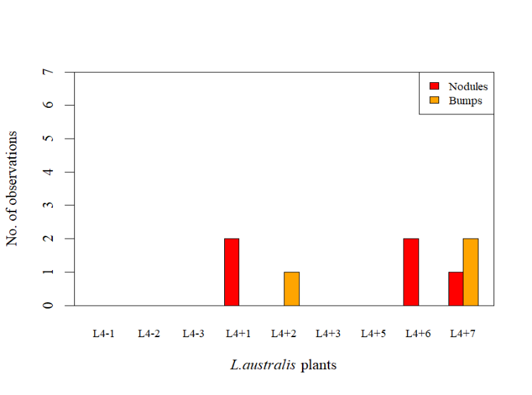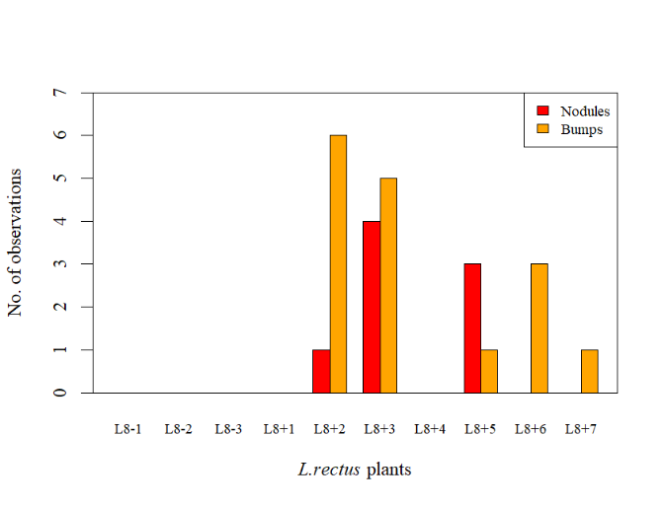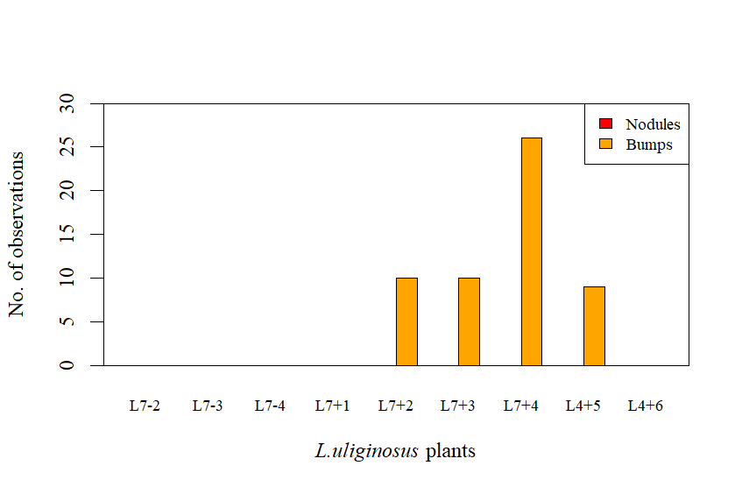

**a)**

**c)**

**b)**

**Fig 1.** Species-specific results of the Nodulation Assessment. Counts of symbiosis indicators (“Nodules” and “Bumps”) for each subject of each species. Subjects with a “-” indicate a negative control (not inoculated) while subjects with a “+” indicate that inoculation with *M. australicum* BR1-1-5xICE*Ml*Sym occurred. **a)** *L.rectus* Tas2206 **b*)*** *L. australis* ID#3 **c)** *L. uliginosus* GLOC005.

**Results**

**Nodulation assessment**

*L. rectus* Tas2206

Of the seven *L. rectus* Tas2206 seedlings inoculated with *M. australicum* BR1-1-5xICE*Ml*Sym, five displayed any signs of rhizobia symbiosis. All five presented with small orange bumps, which may be evidence of the beginnings, or an attempt, at nodulation. Of these five, only three plants (S1) presented with developed nodules (L8+2: 1, L8+3: 4, L8+5: 3) (Fig.1a). When considering both nodules and bumps, *L. rectus* Tas2206 had an 88.9% success rate of establishing a symbiosis.

*L*. *australis* ID#3.

Of the seven *L*. *australis* ID#3 seedlings inoculated, four displayed signs of rhizobia symbiosis. L4+2 and L4+7 each presented with 1-2 small green. Three subjects (S2) presented with well-developed green nodules (L4+1: 2, L4+6: 2, L4+7:1). (Fig.1b). Unlike *L. rectus*, only one of the *L*. *australis* nodule-presenting plants also displayed a bump (L4+7). While 55.6% if the inoculated subjects displayed signs of symbiosis, it would be inaccurate to report this as a “success rate” as no *M. australicum* was recovered from these subjects.

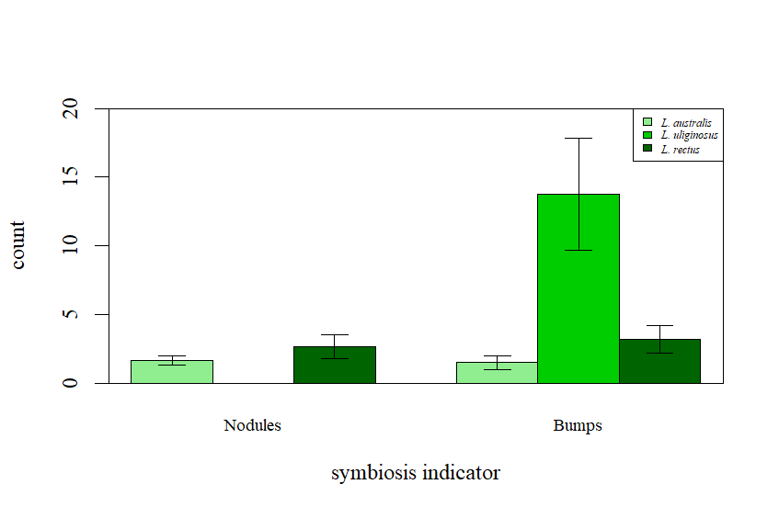

**Fig 2.** Comparison of average (±95%CI) counts of symbiosis indicators, “Nodules” and “Bumps”, organised by *Lotus* species (*L. australis* ID#3*, L. uliginosus* GLOC005, *L. rectus* Tas2206). Sample sizes for each group are as follows: Nodules: *L. australis* ID#3:n = 3, *L. uliginosus* GLOC005: n = 0, *L. rectus* Tas2206: n = 2. Bumps: *L. australis* ID#3:n = 2, *L. uliginosus* GLOC005: n = 4, *L. rectus* Tas2206: n = 5.

*L. uliginosus* GLOC005

None of the seven inoculated *L. uliginosus* GLOC005 subjects displayed nodules. However, four subjects (S3a, S3b) displayed a series of small orange bumps (L7+2: 10, L7+3: 10, L7+4: 26, L7+5: 9) (Fig.1c). Overall, 44.4% of inoculated subjects displayed bumps. However, as *M. australicum* failed to be recovered, these bumps can only be considered attempts at symbiosis (similar to *L. australis*) rather than actual reports of symbiosis (as with *L. rectus*).

**Weight assay**

When considering weight as a function of symbiosis state (no nodules, nodules and/or bumps, nodule presenting, bumps only) the data successfully met all ANOVA assumptions. Homogeneity of variance was mostly confirmed by the relatively flat line in the Residuals vs Fitted Values plot (S4a). The sudden shift at the midpoint displays that there are two slightly distinct trends in the variance. However, the implications of this were uncertain, and so a Levene’s Test was conducted to further test variance homogeneity. This test did not reject the null hypothesis (F3,8 = 0.250, p = 0.8591), thus supporting the decision that the variance is reasonably homogenous.

Normality of data was also confirmed by reasonable degree of linearity in the Normal Q-Q plot (S4b).

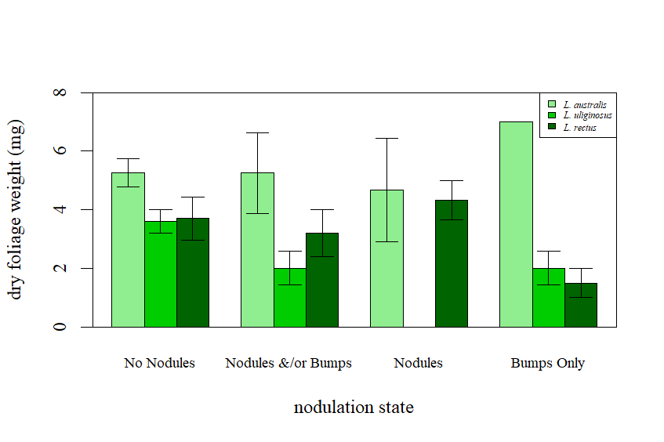

**Fig 3.** Comparison of average (±95%CI) dry foliage weight (mg) sorted by nodulation state, “No Nodules”, “Nodules and/or Bumps”, “Nodules” (includes plants that possess either nodules only, or nodules and bumps), “Bumps Only” (excludes plants with nodules and bumps), organised by *Lotus* species (*L. australis* ID#3*, L. uliginosus* GLOC005, *L. rectus* Tas2206). Sample sizes for each group are as follows: No Nodules: *L. australis* ID#3:n = 4, *L. uliginosus* GLOC005: n = 5, *L. rectus* Tas2206: n = 5. Nodules &/or Bumps: *L. australis* ID#3:n = 4, *L. uliginosus* GLOC005: n = 4, *L. rectus* Tas2206: n = 5. Nodules: *L. australis* ID#3:n = 3, *L. uliginosus* GLOC005: n = 0, *L. rectus* Tas2206: n = 3. Bumps Only: *L. australis* ID#3:n = 1, *L. uliginosus* GLOC005: n = 4, *L. rectus* Tas2206: n = 2.

The One-Way ANOVA found no significant interaction between symbiosis state and weight of the cuttings (F3,8 = 0.145, p = 0.9300) (Fig. 3). This indicates that the symbiotic *M. australicum* BR1-1-5xICE*Ml*Sym did not provide its plants with nitrogenous compounds; or at least, not enough to significantly benefit its host’s biomass. Thus, it appears that the bacterium was incapable of utilising the nitrogen-fixing genes of the ICE*MI*Sym.

**Colony assessment**

All plates inoculated with the nodule suspension prepared from subjects L8+2, +3 and +5 displayed bacterial growth. Each isolate possessed a similar morphology of green, irregularly shaped, wet colonies. No secondary isolates or contaminants were observed, indicating a pure culture. The fact that the colonies appeared identical across nodules from all three assessed plants is strong evidence that the recovered isolate is the same bacteria used in the initial seedling inoculation, *M. australicum* BR1-1-5xICE*Ml*Sym. This displays that the bacteria were able utilise the symbiosis genes of ICE*Ml*Sym, at least to the extent of colonising the roots of *L. rectus* Tas2206.

In contrast, the plates inoculated with the suspension from *L. australis* ID#3 and *L. uliginous* GLOC005 root cuttings displayed no growth. This indicates that although symbiosis initially began (as evidenced by the nodules/bumps), the plant eventually rejected the *M. australicum* symbiont at a

later point during nodulation6. Without the nutrients from the host plant, the bacteria died in the nodule.

**Table 1**. Cu MIC *Trial II* results. MIC measures are based on the 1:107 diluted inoculation patch of each bacteria’s series dilution. The *Pseudomonas* species of the “strains” listed refer to *P. protegens* for Pf5, and *P. stutzeri* for 17578, 17641 and Q. Strains 17641 and Q are carries of the IME of interest, while Pf5 and 17578 are negative controls.



**Cu MIC Assay**

*Trial I* of the Cu MIC assay produced unexpected results. While they displayed good growth on the 0mM plate, no growth was observed on plates with Cu ≥ 0.8mM. However, the subsequent quality assessment of the media went as expected. The Cu-tolerant colonies sampled from Phyllo-C (grown on Cu 300mg/L), Phyllo-C (grown on Cu 200mg/L), and Rhizo-C (grown on Cu 200mg/L) all displayed good growth on 0mM, 0.8mM and 1.0mM plates. Moreover, the Cu-sensitive "Phyllo B" colonies grew well on the 0mM plate, but displayed minimal to no growth on the 0.8mM and 1.0mM plates. These results display that absence of growth in *Trial I* was not the result of faulty MGY preparation, but instead an indication that the lowest Cu concentration of 0.8mM was above the Cu tolerance level of the isolates.

*Trial II* of the Cu MIC also produced unexpected, albeit interpretable, results. As displayed in **Table 1**, the four strains varied in their tolerance to Cu. When comparing the most diluted inoculation patch of the dilution series, 1:107, *P. protegens* Pf5 displayed the greatest resistance (MIC: 0.6mM), followed by *P. stutzeri* 17587 and *P. stutzeri* Q (MIC: 0.3mM), with *P. stutzeri* displaying the least resistance 17641 (MIC 0.0mM). These results support the hypothesis that the absence of growth in *Trial I* was largely due to testing Cu concentrations above the tolerance level of the isolates. However, it is important to note that while no dilution patches grew on any plates with Cu ≥ 0.8mM, some of the more densely concentrated inoculation patches for *P. protegens* Pf5, *P. stutzeri* 17587 and *P. stutzeri* Q displayed MIC’s of >1.0mM. *P. stutzeri* 17641 also displayed MIC’s of 1.0mM for some of its more densely concentrated patches. Therefore, an error in plate preparation for *Trial I* may be partially to blame for these inconsistencies.

It should be noted that the Trial II MIC for *P. stutzeri* 17641 was complicated by contamination. While the initial inoculation patches appeared as expected (small translucent colonies), the 1:105 patch possessed large fluorescent colonies. These colonies were immediately deemed as odd, as *P. stutzeri* is typically distinct from many other *Pseudomonas* spp. specifically due to its lack of fluorescent pigments9. However, these colonies appeared near identical to those of *P. protegens* Pf5, and so the abnormality was attributed to an error in preparation of the serial dilution that resulted in contamination. However, it appears that this preparation error may have also resulted in solutions for 1:106 and 1:107 missing their inoculants. This would explain the surprisingly low MIC of 0mM for the *P. stutzeri* 17641 1:107 patch. However, even without this error it is unlikely that the Cu MIC results would have indicated anything much higher. All higher inoculation patches had displayed little growth by Cu 0.6mM, and absolutely no growth on Cu 1.0mM. As such, it is reasonable to assume that *P. stutzeri* 17641’s true Cu MIC would be something similar to the other IME carrier, *P. stutzeri* Q, with a 1:107 Cu MIC of 0.3mM.

**Discussion**

**Rhizobia symbiosis rates differed between different *Lotus* spp.**

*L. rectus* Tas2206 was more receptive to symbiosis with *M. australicum* BRC1-1-5xICE*Ml*Sym than *L. autralis* ID#3 or *L. uliginosus* GLOC005. This is reflected by its higher rates of nodules and bumps (88.9%) compared to the other two species (55.6% and 44.4%, respectively). This is further supported by the colony morphology assessment, wherein *L. rectus* Tas2206 was the only species from which *M. australicum* BRC1-1-5xICE*Ml*Sym was successfully recovered.

These results make *L. rectus* Tas2206 a promising candidate with which to continue the evolutionary experiment. At face value, *L. autralis* ID#3 and *L. uliginosus* GLOC005 are less promising by comparison. However, the relatively small number of assessable inoculants (n=6 for both species) should be taken into account. While symbiosis between *M. australicum* BRC1-1-5xICE*Ml*Sym is limited in this particular trial, increasing the pool of inoculated subjects may increase the chances of a successful symbiosis. An increase in the number of replicants for *L. australis* is already underway. A second set of ID#3 seedlings, as well as seedings from an alternative plant, *L. australis* SA17133, were prepared as part of the *Seed Inoculation* procedure described. The future nodulation assessment of these shoots can be collated with the results of this study to provide a more comprehensive display of *M. australicum* BRC1-1-5xICE*Ml*Sym's ability to form symbiosis with *L. australis*. Increasing the sample size for *L. uliginosus* GLOC005 would have similar statistical benefits.

**Presence of symbiosis indicators did not correlate with greater dry foliage weight**

The One-way ANOVA did not find any significant interaction between the presence of symbiosis indicators and the dry foliage weight of the plants. This indicates that the symbioses between *M. australicum* BR1-1-5xICE*Ml*Sym and the *Lotus* spp. did not involve any nitrogen fixation; or at least, not enough nitrogen fixation to cause a detectable change in plant biomass. While unfortunate, this finding is not entirely unexpected. *M. australicum* BR1-1-5 is typically considered a non-symbiotic strain of *Mesorhizobium*4. Its symbiotic properties are dependent on its ability to utilise the genes on the ICE*Ml*Sym4, which is what the planned evolutionary experiment is aimed to select for. As such, for a first round of the exepriement, such lack of significant nitrogen fixation it typical.

However, it is important to note the red pigment observed in the nodules of *L. rectus* Tas2206, as well as the orange hue of the bumps of *L. uliginosus* GLOC005. This red pigment is the result of leghaemoglobins in the plant cells of the nodules10. These leghaemoglobins are an essential component of the symbiotic nitrogen fixation process10. Thus, the red nodules and orange bumps suggest that nitrogen fixation was attempted to some extent. In contrast, *L. australis* ID#3 displayed nodules and bumps that simply matched the green colour of the surrounding root. This lack of red pigment is further evidence of a failure to establish successful symbiosis with this legume.

**Cu MIC failed to identity IME in *Pseudomonas* spp.**

The results of the Cu MIC were not as expected. The IME carriers, *P. stutzeri* 17641 and *P. stutzeri* Q did not display a greater Cu MIC than the negative controls, *P. stutzeri* 17578 and P. *protgenens* Pf5. Dr Colombi had believed that the IME carried a Cu resistance gene, and thus growth on Cu would act as a reliable positive selection control. However, as *P. stutzeri* 17641 and *P. stutzeri* Q have been previously confirmed by Dr Colombi to possess the IME, the notion that the IME is simply absent in these strains is unlikely to explain the assay results. Instead, it was hypothesised that the functional annotation of the Cu gene might be incorrect. This is plausible if the gene annotation is derived by computational homology, as opposed to experimental verification. Therefore, before experiments involving the transmission of IME between cells can begin, a different and more reliable IME selective marker must be identified and verified.

**Conclusions**

This study aimed to optimise a planned evolutionary experiment targeted at evolving *M. australicum* BR1-1-5xICE*Ml*Sym to utilise its nitrogen-fixation genes and form a successful symbiosis with various species of *Lotus* legumes. *L. rectus* Tas2206 was most receptive to *M. australicum* BR1-1-5xICE*Ml*Sym, whereas *L. australis* ID#3 and *L. uliginosus* GLOC005 displayed little-to-no success. While some *Lotus* subjects displayed characteristic indicators of nitrogen-fixing symbiosis, this was not correlated with any significant change in biomass. Of the three *Lotus* plants assayed, *L. rectus* Tas2206 appears to be the most promising candidate with which to pursue the *M. australicum* BR1-1-5xICE*Ml*Sym evolutionary experiment.

This study also aimed to confirm that Cu resistance was a reliable selective marker for identifying bacteria carrying an IME of interest. However, the Cu MIC involving various *Pseudomonas* spp. displayed no increase in Cu MIC for the positive controls. As such, Cu resistance is an unreliable indicator, and a different selection marker must be investigated.

**Data Availability**

Raw notes and records from my lab book are available in the PDF file, *Placement1_LabBook_IsaakSalami_46625143* accompanying this report. Supplementary figures, consisting of photos of various *Lotus* subjects and ANOVA assumption testing plots are available in the *Supplementary Material* PDF accompanying this report. Datasets and R scripts used to generate bar plots and ANOVA reports are available at <https://github.com/isaak11salami/FOSE7901_Placement1>

**Acknowledgements**

I would like to thank my supervisor, Dr Elena Colombi, for their patience and guidance throughout the course of this placement, as well as for looking over the first draft of this report and proving valuable feedback. I would also like to thank Nishadi Samarakoon for letting us use her copper-sensitive and copper-resistant phyllo- and rhizosphere isolates in the Cu MGY quality test. Finally, I would like to extend my gratitude to the entire EMMA lab for making me feel welcome and accepted, both in meetings and in the lab, during my time with them in this placement.

**References**

1. Oldroyd, G. E. D. Speak, friend, and enter: signalling systems that promote beneficial symbiotic associations in plants. *Nat. Rev. Microbiol.* **11**, 252–263 (2013).

2. Johnson, C. M. & Grossman, A. D. Integrative and Conjugative Elements (ICEs): What They Do and How They Work. *Annu. Rev. Genet.* **49**, 577–601 (2015).

3. Colombi, E. *et al.* Comparative analysis of integrative and conjugative mobile genetic elements in the genus Mesorhizobium. *Microb. Genomics* **7**, 000657 (2021).

4. Colombi, E. *et al.* Population genomics of Australian indigenous Mesorhizobium reveals diverse nonsymbiotic genospecies capable of nitrogen-fixing symbioses following horizontal gene transfer. *Microb. Genomics* **9**, 000918 (2023).

5. Guédon, G., Libante, V., Coluzzi, C., Payot, S. & Leblond-Bourget, N. The Obscure World of Integrative and Mobilizable Elements, Highly Widespread Elements that Pirate Bacterial Conjugative Systems. *Genes* **8**, 337 (2017).

6. Wang, D., Yang, S., Tang, F. & Zhu, H. Symbiosis specificity in the legume – rhizobial mutualism. *Cell. Microbiol.* **14**, 334–342 (2012).

7. Posit team. RStudio: Integrated Development Environment for R. Posit Software, PBC (2025).

8. Microsoft® Excel® for Microsoft 365 MSO 64-bit. Microsoft Corporation.

9. Lalucat, J., Bennasar, A., Bosch, R., García-Valdés, E. & Palleroni, N. J. Biology of Pseudomonas stutzeri. *Microbiol. Mol. Biol. Rev.* **70**, 510–547 (2006).

10. Downie, J. A. Legume Haemoglobins: Symbiotic Nitrogen Fixation Needs Bloody Nodules. *Curr. Biol.* **15**, R196–R198 (2005).